# Push Notification using Azure Notification Hub in your UWP app

**Completion Time : ~30 minutes**

**Pre-Requisite**: You need to have a **Windows App Publisher Account**. (refer Section 3 in this document)

1. Start **Visual Studio 2015 > File > New > Project > Visual C# Universal (template)**
2. Create a blank app and give it a Name-  
   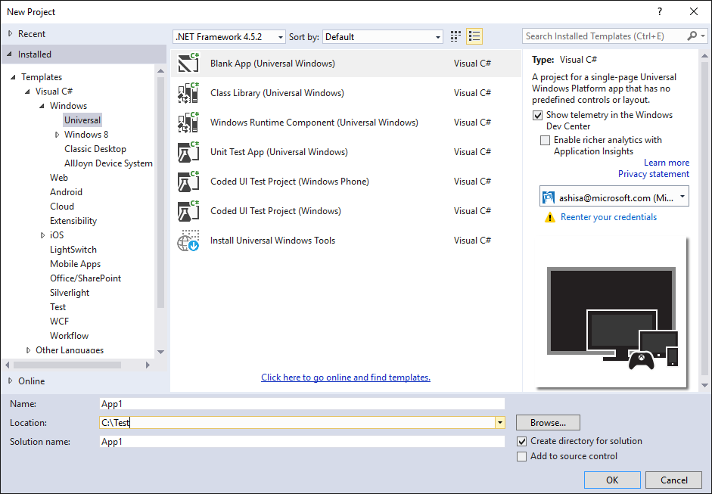
3. Right Click the project from Solution Explorer> **Manage Nuget Packages** > Browse – “**WindowsAzure.Messaging.Managed”** and Install it.

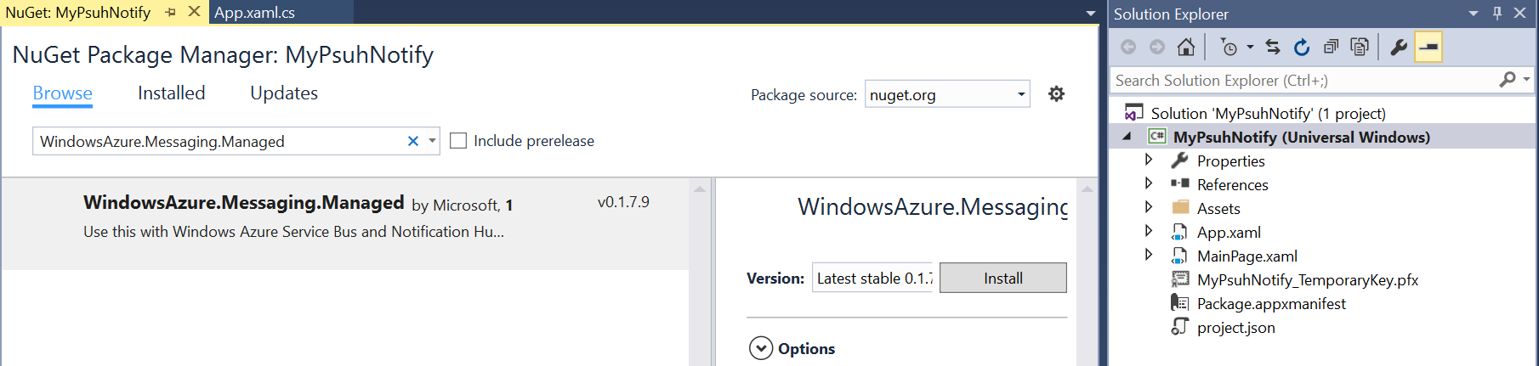

1. Go to MainPage.Xaml.cs and paste the below code. Lets replace the connecting string and Hub name in a while.

private async void InitNotificationsAsync()

{

var channel = await PushNotificationChannelManager.CreatePushNotificationChannelForApplicationAsync();

var hub = new NotificationHub("<HubName>", "<Your Connection String>");

var result = await hub.RegisterNativeAsync(channel.Uri);

// Displays the registration ID so you know it was successful

if (result.RegistrationId != null)

{

var dialog = new MessageDialog("Registration successful: " + result.RegistrationId);

dialog.Commands.Add(new UICommand("OK"));

await dialog.ShowAsync();

}

}

1. Add the below name spaces:-

using Microsoft.WindowsAzure.Messaging;

using Windows.Networking.PushNotifications;

using Windows.UI.Popups;

1. Lets associate the app with the store.

Right Click Project > **Store** > **Associate App with the Store**

1. Login to your Windows Store Account

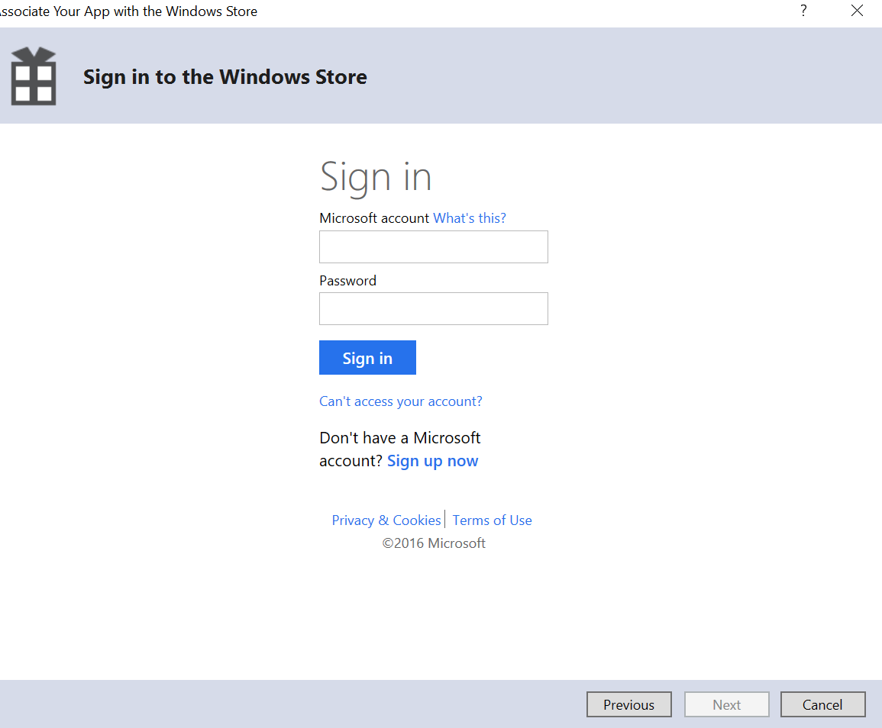

1. Reserve a **new App Name** for your Notification App:

Choose it and **Associate**

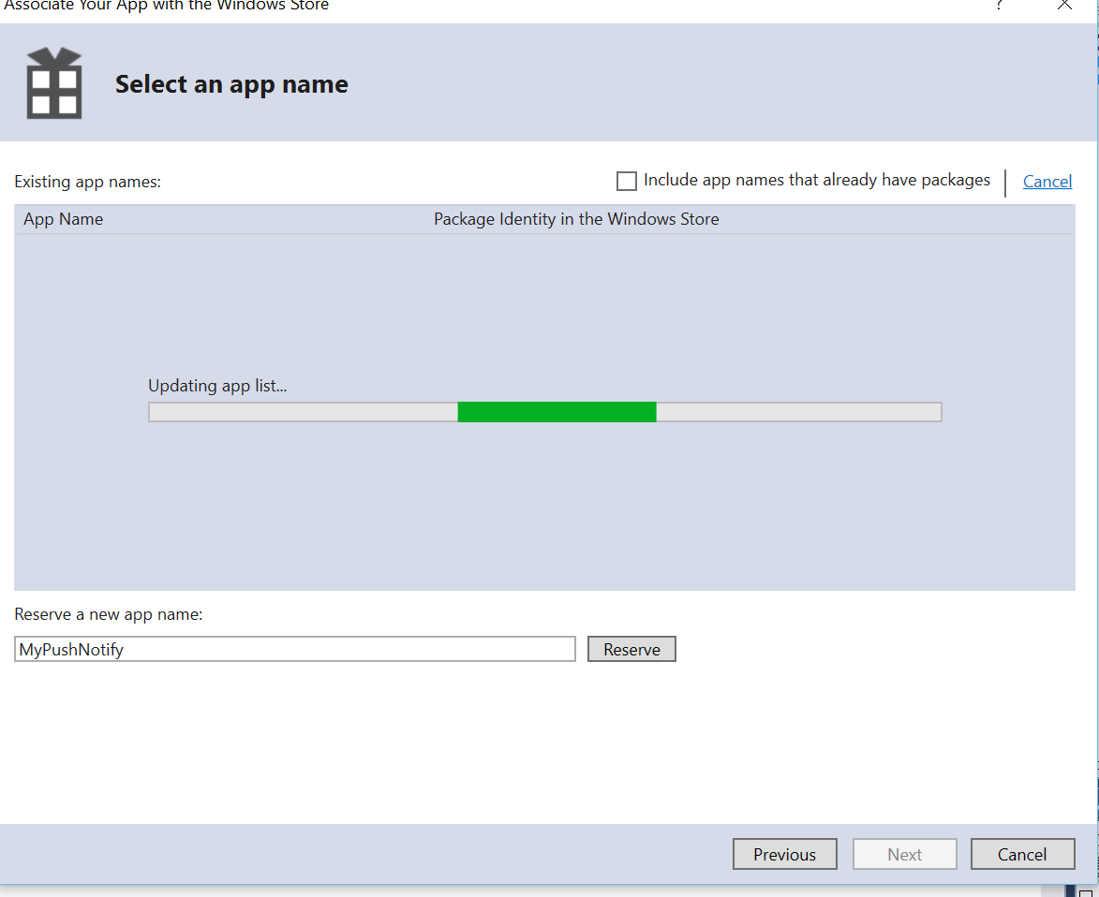

1. Go to <https://dev.windows.com/en-us> > Sign in > **Dashboard** > Go to your App Namne which you just **reserved** from Visual Studio > **Services** > **Push Notification**

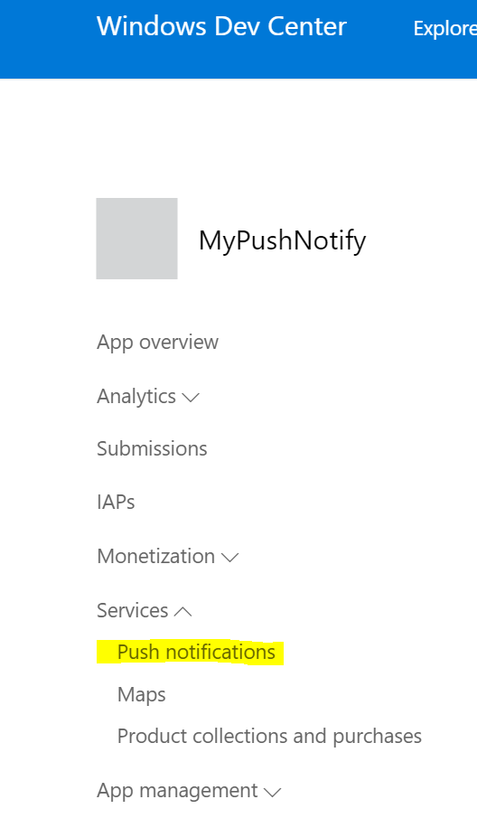

1. Go to **Live Services Site**.

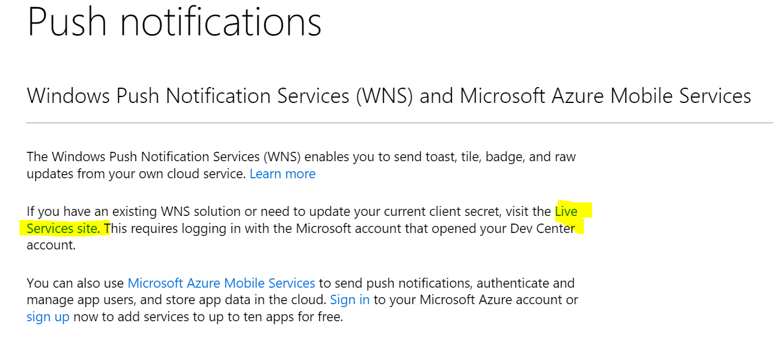

1. Go to App Settings and Note down the **Package SID and Client Secret**

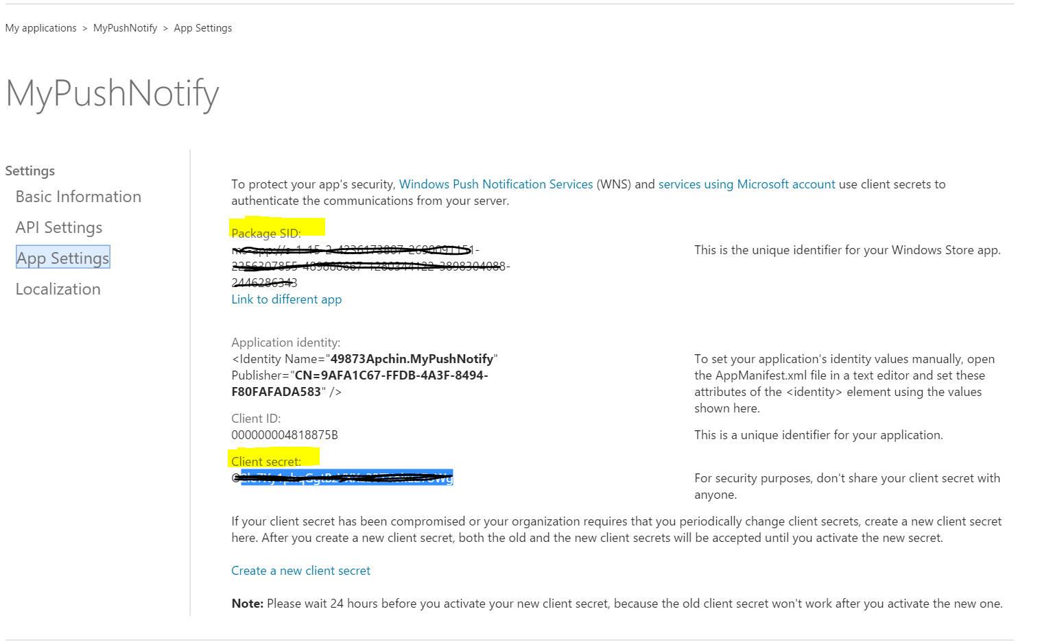

1. Go to <https://ms.portal.azure.com/>
2. **New** > **Web +Mobile** > **Notification Hub**

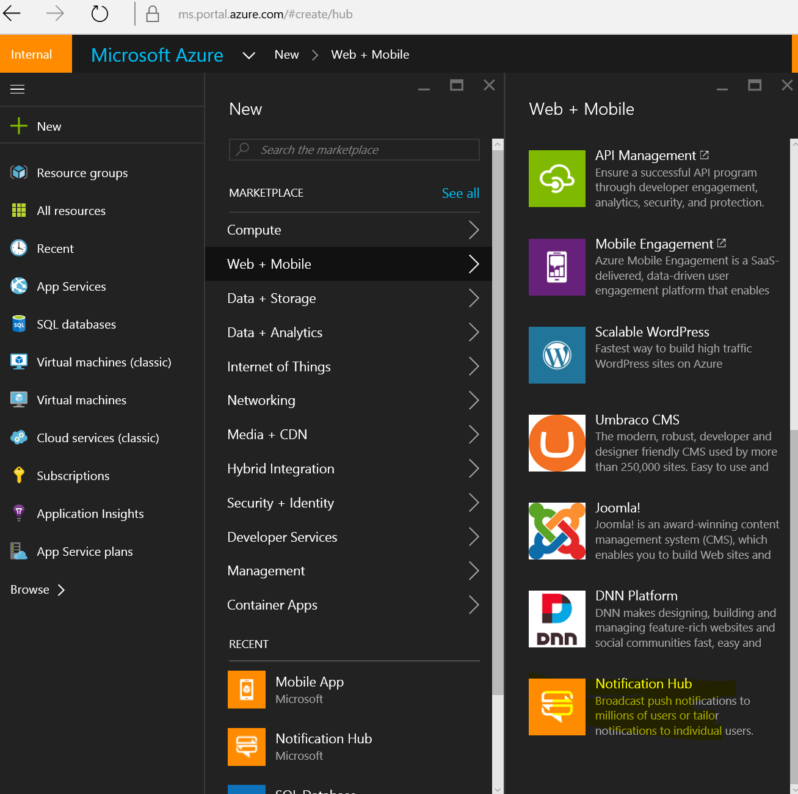

1. Give a unique Name and Namespace for your Notification Hub and click Create.

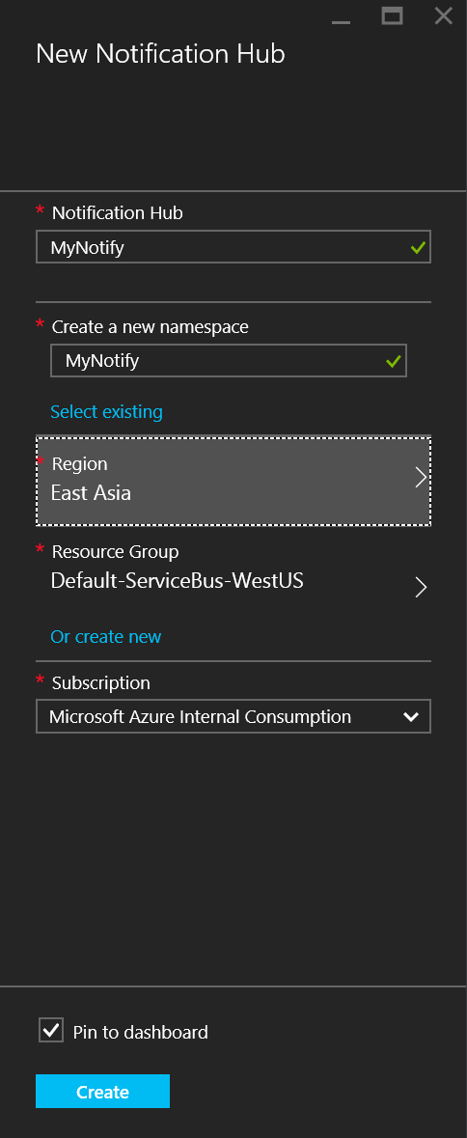

1. Once deployed go to Push Notification Services > Windows WNS.
2. Enter the **Package SID and Security Key** obtained from associating your UWP to the Windows Store.

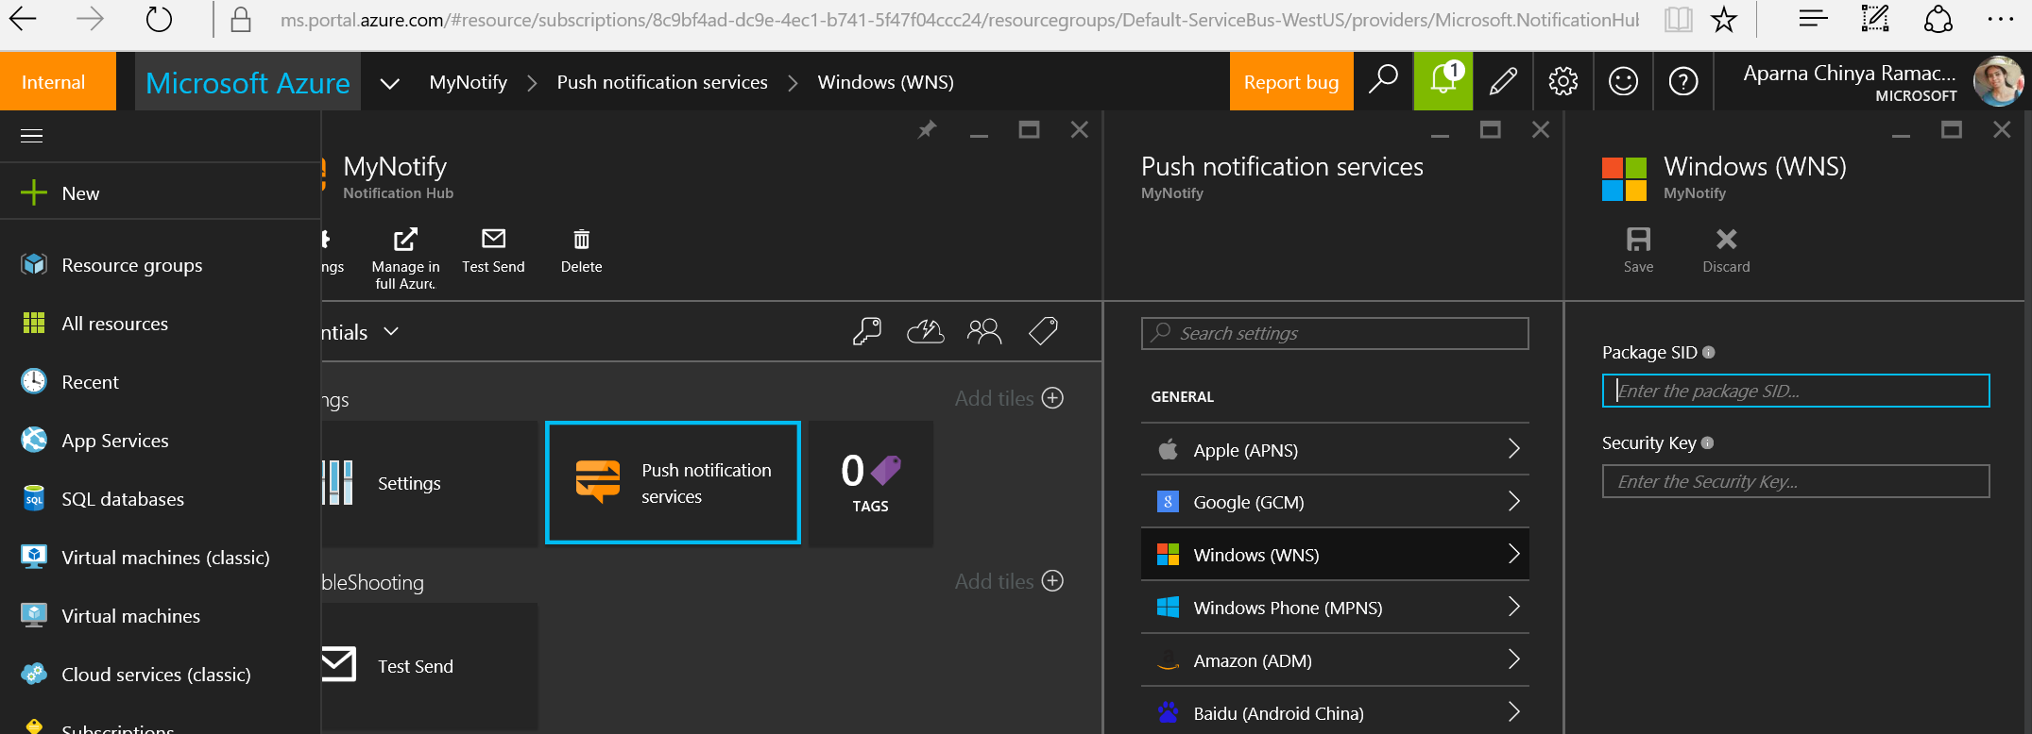

1. Notification Hub Should be successafully created!

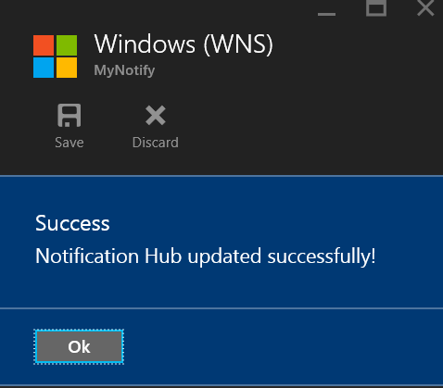

1. Go to the Settings of your Notification Hub > Access Policies > Copy value of **connection string** of **DefaultFullSharedAccessSignature.**

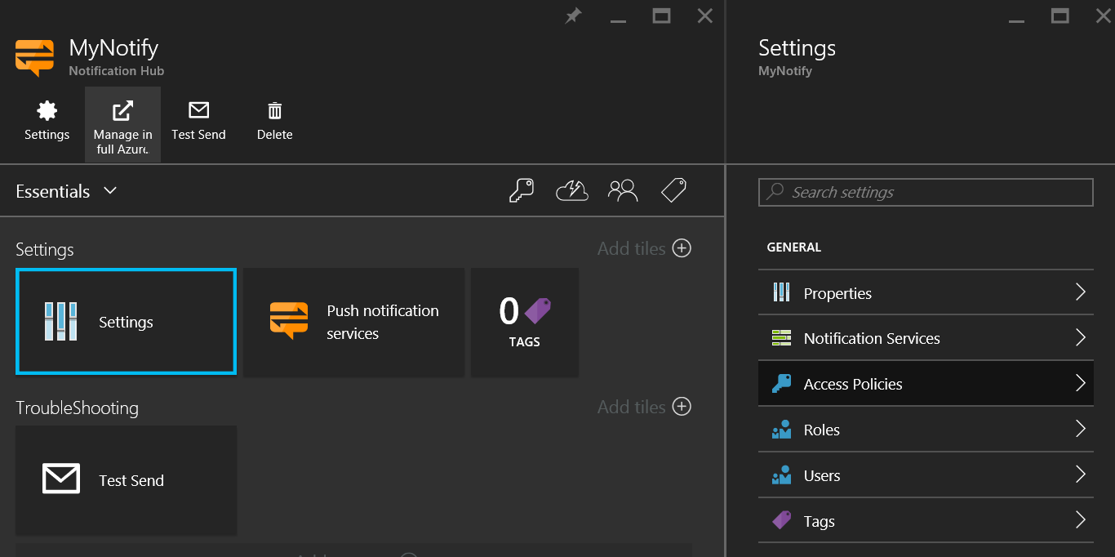

1. Go to your UWP app and replace the Notification Hub Name and connection String in the line : - var hub = new NotificationHub("<HubName>", "<Your Connection String>");
2. Call the InitNotificationsAsync() function in the constructor.
3. Run your UWP app. You should see a successful registeration Message.
4. Test your Notifications.

Go to Server Explorer > Azure > Notification Hubs > Your Notification Hub > **Test Send** > Type: **Toast** > **Send**

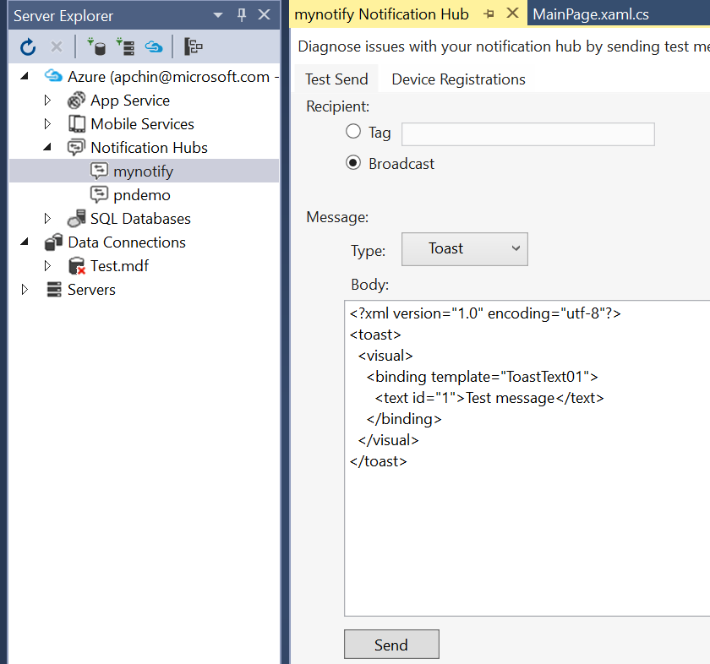

1. You can also send test notifications from the Azure Portal 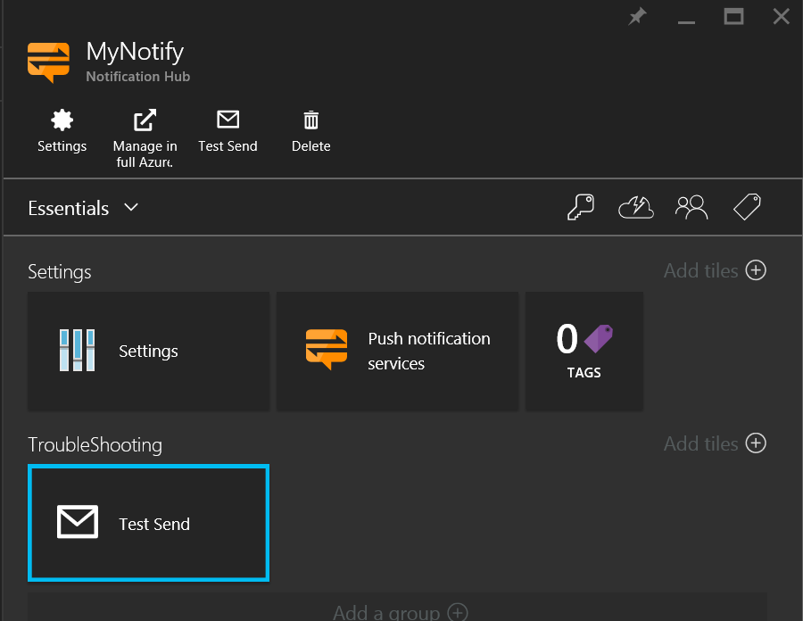
2. You should see a toast notification appearing on all the devices where your UWP was installed.

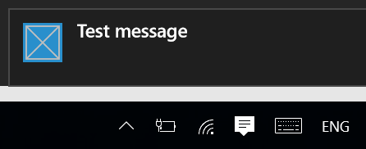

**NOTE**: You can also test sending a push notification from a console app.

Create a **Console application** from Visual studio and use the below function to send push notifications on all the registered devices.

private static async void SendNotificationAsync()

{

NotificationHubClient hub = NotificationHubClient.CreateClientFromConnectionString(

"<Connection String>", "<HubName>");

var toast = @"<toast><visual><binding template=""ToastText01""><text id=""1"">Hello from a .NET App!</text></binding></visual></toast>";

await hub.SendWindowsNativeNotificationAsync(toast);

}

# Using AzureMobile App SDK.

Client - Under App.XAML.CS

private async Task InitNotificationsAsync()

{

   var myChannel = await PushNotificationChannelManager

        .CreatePushNotificationChannelForApplicationAsync();

    await App.MobileService.GetPush().RegisterAsync(myChannel.Uri);

}

**Server(Node.js) script**

//Inside ToDoItem.js

var azureMobileApps = require('azure-mobile-apps'),

promises = require('azure-mobile-apps/src/utilities/promises'),

logger = require('azure-mobile-apps/src/logger');

var table = azureMobileApps.table();

table.insert(function (context) {

logger.info('Running TodoItem.insert');

var payload1 = "Item Added: " +context.item.text ;

return context.execute()

    .then(function (results) {

        if (context.push) {

            context.push.wns.sendToastText01(null, payload1, function (error) {

                if (error) {

                    logger.error('Error while sending push notification: ', error);

                } else {

                    logger.info('Push notification sent successfully!');

                }

            });

        }

        return results;

    })

    .catch(function (error) {

        logger.error('Error while running context.execute: ', error);

    });

});

module.exports = table;

 =============================================================